I Am Important !

I am growing up! I am independent. I am responsible. I am a helper. I am part of my family. A family works together to keep our home tidy and a calm and fun space. When grownups go to work, they earn money. When I am responsible, I earn money too!

My Responsibilities …
I can get ready for school. 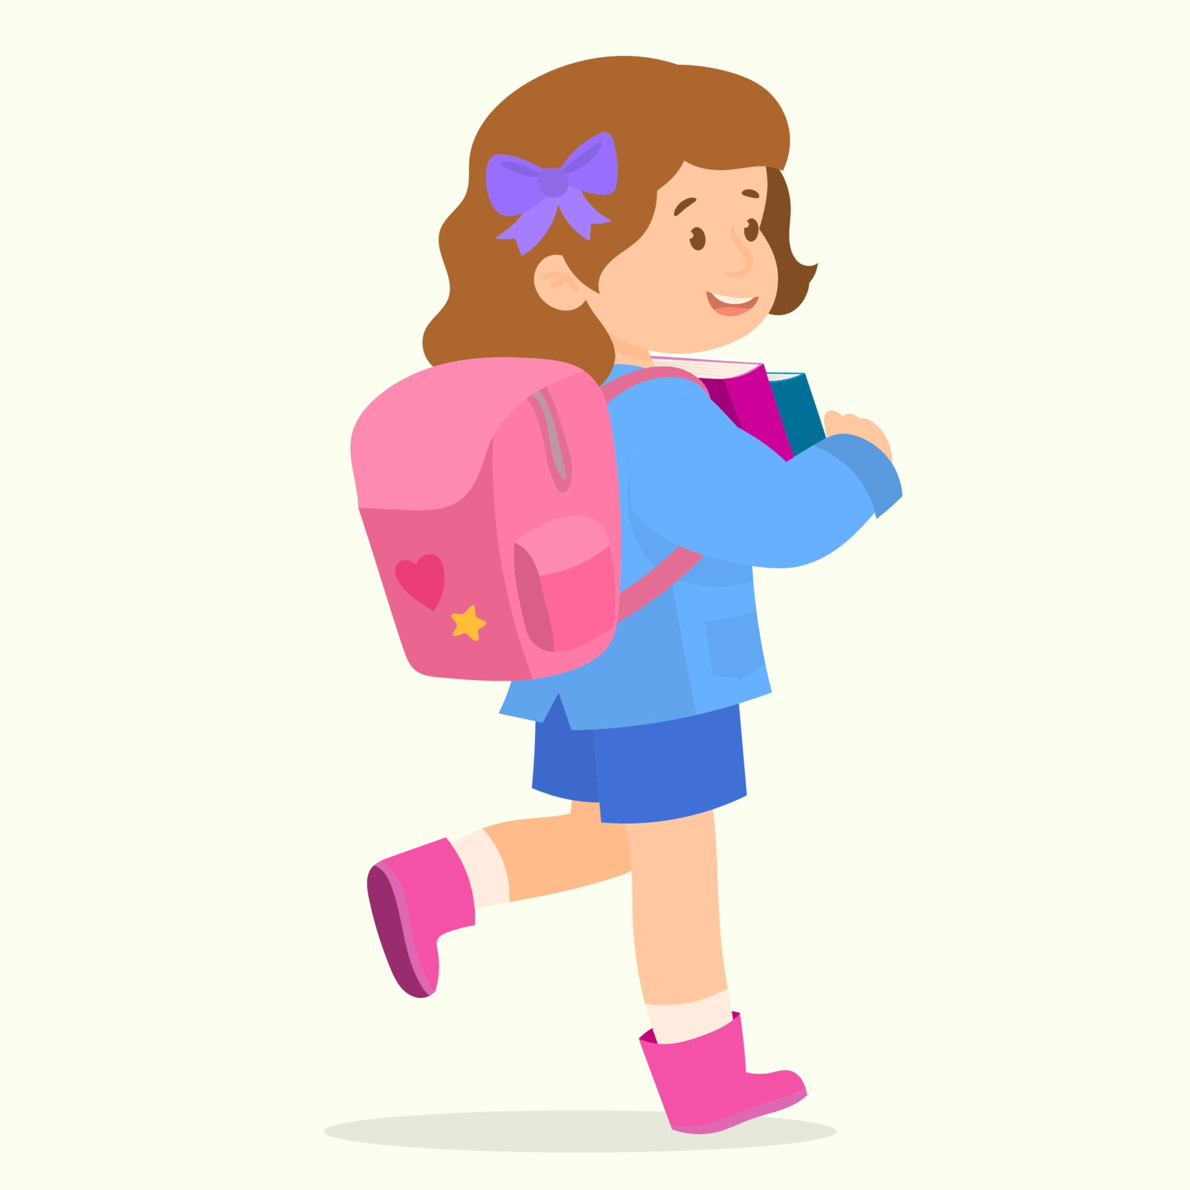
I can put away my toys. 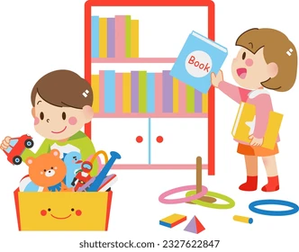
I can get ready for bed. 
Follow instructions. 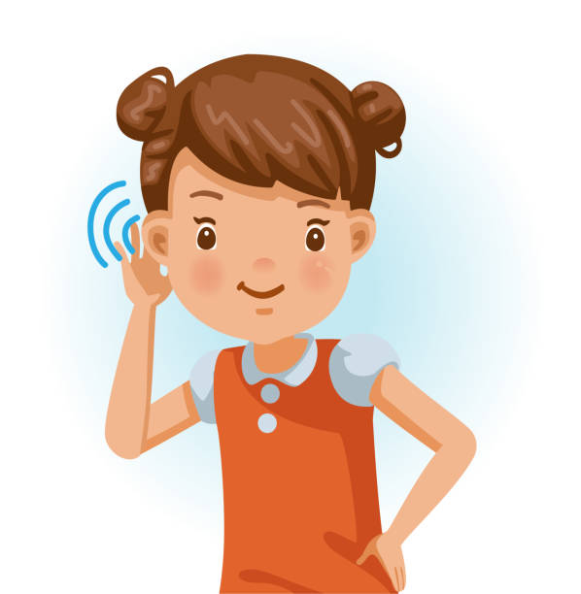
I can do my best work at school. 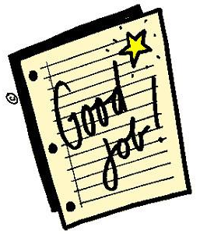
I Am Important !

I am growing up! I am independent. I am responsible. I am a helper. I am part of my family. A family works together to keep our home tidy and a calm and fun space. When grownups go to work, they earn money. When I am responsible, I earn money too!

My Responsibilities …

